Version <1.0>

Revision History

|  |  |  |  |
| --- | --- | --- | --- |
| **Date** | **Version** | **Description** | **Author** |
| 17/12/2020 | <1.0> | <details> | Do Minh Hieu |
|  |  |  |  |
|  |  |  |  |
|  |  |  |  |

Table of Contents

1. Introduction 4

1.1 Purpose 4

1.2 Scope 4

1.3 Definitions, Acronyms, and Abbreviations 4

1.4 References 4

1.5 Overview 4

2. Use-Case Specification 4

3. Interaction Diagrams 5

4. Class Diagrams 6

5. Derived Requirements 7

# Introduction

## Purpose

This document describes how the Login Use-Case is realized within the design model, in terms of collaborating objects.

## Scope

This document applies to the Image Gallery Software which will be developed Group 5C-18.

## Definitions, Acronyms, and Abbreviations

User – a person who use the software.

## References

None.

## Overview

In the following section, Use-Case Realization Specification of the Login Use-Case of the Image Gallery Software is provided in detail. The first section is a textual description of the Use-Case specification. The following section contains diagrams (sequence and collaboration diagrams) describing how the use case is realized in terms of collaborating objects. The third section includes class diagrams with relationships that participate in the realization of the use case. The last section is an analysis of all requirements, such as non-functional requirements, on the use-case realization that are not considered in the design model, but that need to be taken care of during implementation.

# Use-Case Specification

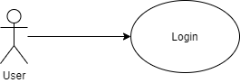

|  |  |
| --- | --- |
| **Name** | Login |
| **Brief Description** | A user loging in to the system |
| **Actor** | User |
| **Flow of Events** | |
| **Basic Flow** | |
| 1. User open login page. 2. The system prompts user for a username and password. 3. The user enters their username and password. 4. The system verifies username and password. 5. The system authenticates the user. 6. The system grants the user an authentication token for the current session. | |
| **Alterante Flows** | |
| **Title** | **Description** |
| Authentication fail | 1. User enter invalid username or password 2. System displays message to correct invalid information. |
| **Pre-Conditions** | |
| Not empty field. | |
| **Post-Conditions** | |
| **Title** | **Description** |
| Success | Success message is prompted and user enter homepage screen. |
| Failure | The user is unable to login because invalid username or password and an error is prompted. |
| **Extension Points** | |
| None | |

# Interaction Diagrams

**Sequence Diagram:**

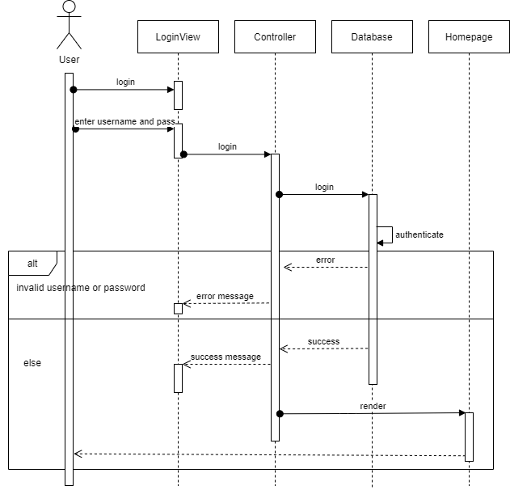

**Collaboration Diagram:**

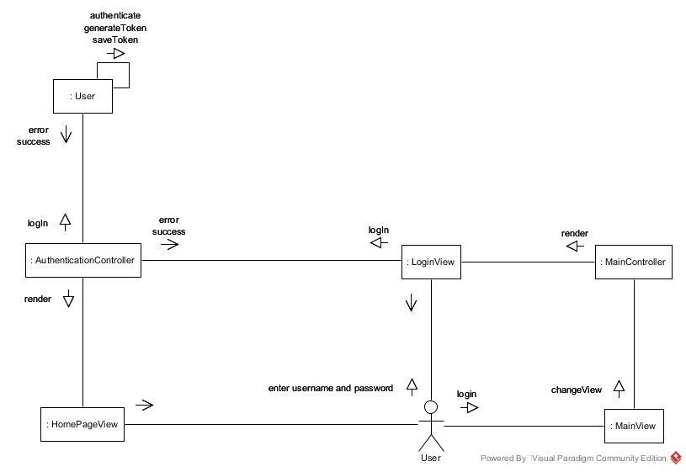

# Class Diagrams

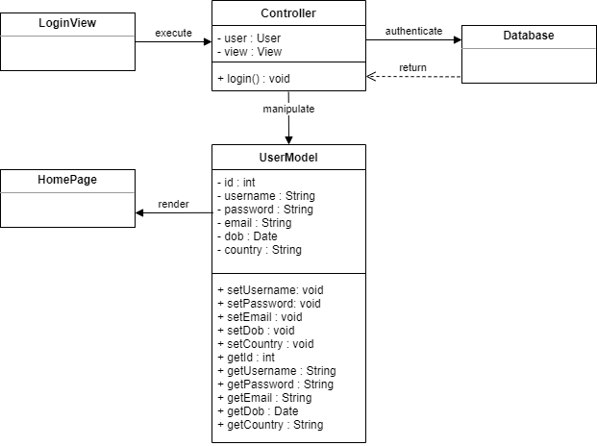

# Derived Requirements

None.